 

Learning From Data

Multilayer layer neural network “**MLNN**” (Task 2)

Banknote Authentication Problem

|  |  |
| --- | --- |
| Name | ID |
| فؤاد سيد فؤاد | 20200384 |
| حسن سمير حسن | 20200154 |
| حسن تامر علي | 20200152 |
| أحمد سامح أحمد | 20200015 |
| سارة صاموئيل لمعي | 20200217 |

اشراف: ا. د. الشيماء الجندي

2022م-2023م

Confusion Matrix

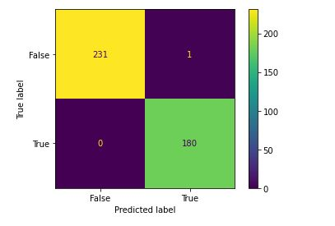

* True Positive = 231
* False Positive = 1
* True Negative = 180
* False Negative = 0

ROC Curve

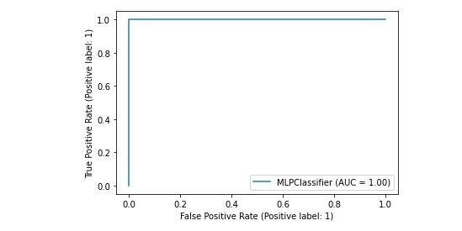

An ROC Curve (Receiver Operating Characteristic Curve) is a graph showing the performance of a classification model at all classification thresholds. This curve plots two parameters:

* True Positive Rate
* False Positive Rate

True Positive Rate (TPR) is a synonym for recall and is therefore defined as follows:

* TPR = (TP)/(TP+FN)

False Positive Rate (FPR) is defined as follows:

* FPR = (FP)/(FP+TN)

An ROC curve plots TPR vs. FPR at different classification thresholds. Lowering the classification threshold classifies more items as positive, thus increasing both False Positives and True Positives. The following figure shows a typical ROC curve.

Network Architecture (Classification)

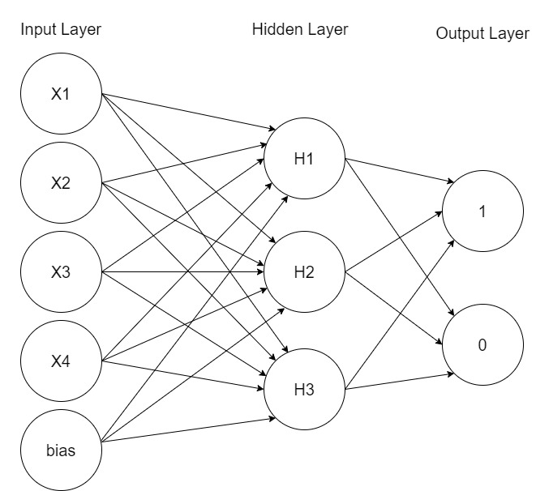

* Input Layer → 5 Neurons
* Hidden Layer → 3 Neurons
* Output Layer → 2 Neurons